JAVA網路應用#5

工資103 H34996158 侯瑋明

Q1

// MyThread.java

public class MyThread extends Thread

{

public static boolean ready = false;

public MyThread(String name)

{

super(name);

}

public void run()

{

while(!ready){};

System.out.println(getName());

}

}

// MyThreadTest.java

public class MyThreadTest

{

public static void main(String args[])

{

MyThread[] mt = new MyThread[]{

new MyThread("時"), new MyThread("時"), new MyThread("示"), new MyThread("時"), new MyThread("人"),

new MyThread("時"), new MyThread("人"), new MyThread("自"), new MyThread("不"), new MyThread("識")

};

for(int i=0; i<mt.length; i++) //Start the threads

{

mt[i].start();

}

MyThread.ready = true;

}

}

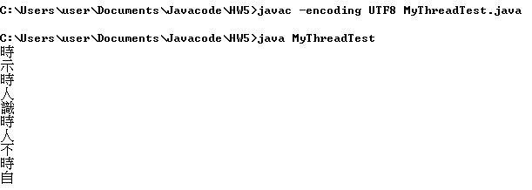

Q2

//Bang.java

public class Bang extends Throwable

{

public Bang(){}

public String toString()

{

return "Bang!! Game Start!!";

}

}

// Horse.java

public class Horse extends Thread

{

int meter;

int step=0;

public Horse(int meter)

{

this.meter = meter;

}

public void run()

{

while(true)

{

setPriority((int)(java.lang.Math.random()\*9)+1);

step += (int)(java.lang.Math.random()\*10);

if(step>=meter)

break;

}

System.out.println("抵達終點, " + Thread.currentThread().getName());

}

}

// HorseRace

public class HorseRace

{

public HorseRace()

{

Horse[] horses = new Horse[5];//建立5匹賽馬

for(int i=0; i<horses.length; i++)

{

horses[i] = new Horse(500);

horses[i].setName("編號" + i);

}

//比賽開始

try{

Gun();

}catch(Bang b){

System.out.println(b);

for(int i=0; i<horses.length; i++)

{

horses[i].start();

}

}

}

public void Gun() throws Bang

{

throw new Bang();

}

public static void main(String[] args)

{

new HorseRace();

}

}

